[**Back to HCI Lab Home Page**](http://iitg.vlab.co.in/?sub=72&brch=170)

**What Constitutes A Control Panel?**

Parts of a product that user interacts with to perform a task constitutes the user interface (UI). A systematic and effective arrangement of user controls and displays of a product makes the control panel. Control panel can also be used to configure product’s internal features.

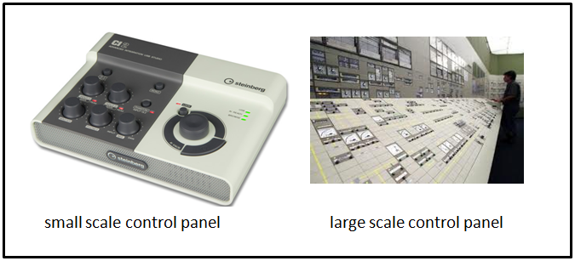

Control panel of electronic equipment comprises of elements like LEDs, displays, lamps, switches, meters, push buttons, dial knobs, fuses, printed instructions, labels, name plate etc. In software products the graphical user interface (GUI) forms the control panel.

The interaction between user and control panel elements need not always be physical. Panel elements like visual displays and audio signals also form a part of user interaction and communication. This applies in case of airplane where entire cockpit constitutes the control panel environment. Cockpit control panel design (both aircraft and space craft) is most challenging design tasks.

Consumer products too have control panel or interface. The interface designer of a domestic appliance needs to simplify operations to perform complex tasks. This can make wide spectrum of users use the domestic appliance with ease without much technical knowhow about the product itself. A microwave oven needs careful design of its controls. Any confusion in its operation can result in serious accidents. The buttons on the keypad of a TV remote control, mobile phone or a portable music player are so small that they are difficult to use or are not used eventually by the users.

Therefore designing of control panel is a creative but technically demanding effort that aims at efficient and aesthetically satisfying human product interaction.

Control panel elements are classified into following categories :

      1. Activation :  for activating a operation  e.g.  switches, push buttons

      2. Discrete :  for setting fixed operational values or inputs e.g. a rotary dial

      3. Continuous:  for varying continues values e.g. dials , slider switches , volume knob

      4. Rapid : for inputing data rapidly e.g. data entry buttons on a keyboard

 To proceed  further  click on the **DESIGN GUIDELINES** tab on the top or to exit this experiment  click on **HOME**  on the top.

[**Back to HCI Lab Home Page**](http://iitg.vlab.co.in/?sub=72&brch=170)

**Guidelines for selecting control elements and panel layout**

Following are the guidelines to be followed while selecting elements and laying out the configuration (designing) of control panels.

1. **Select control element suitable for the task:** Select control elements which suit to the task, satisfy ergonomic demands and are aesthetic in nature. Higher the usability more efficient is the task performance. Task frequency and control-response ratio (C/R = movement of control for getting valid system response of feedback) are to be kept in mind while choosing the elements carefully.

2.  **Organize control elements in a logical grid**. A good control panel or user interface has to fulfill

     ergonomics, aesthetics and engineering requirements.

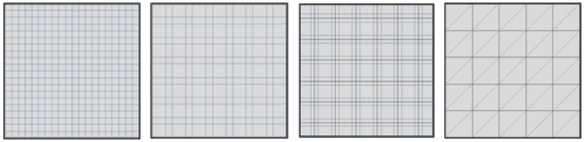

There are three different principles on which a panel layout is determined. They are (a) operational sequence

(b) frequency of use and (c) centre of attention.

**Operational sequence principle**: If there is a fixed sequence of operations in an operating cycle then the control elements are laid in the same sequence from either left or right. Figure below shows (A) a panel with random layout and sequence of operations and (B) another refined panel layout that uses operational sequence principle.

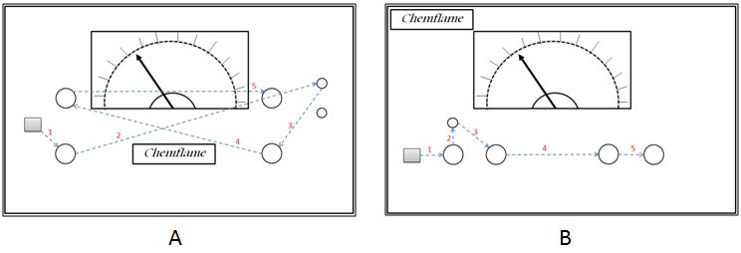

**Frequency of use principle**: Some panel controls are used more frequently than others. In this layout elements are grouped into more frequently used controls and less frequently used controls. The more frequently used controls are colored prominently and put in a visually discernable cluster to distinguish easily as well as placed in a more convenient position to optimize human performance.

**Centre of attention principle**: Some panel elements need to be always a center of attention like alarm displays, important indicators and emergency controls. In this layout such elements are placed at the centre of the panel before fixing other elements around them.

In some equipments such as medical or communication a combination of the above three principles can be employed.

3. **Make the panel aesthetically appealing**: The creative design principle of *"form follows function"* and *"Gestalt’s principles of visual order and beauty"* form the basis of aesthetic decisions. Contrary to belief aesthetic decisions are not taken based on someone’s liking or fancy tastes. Control panels are not art pieces.

 (i)           Elements should be placed in a grid to be visually appealing and organized.

(ii)         Symmetry is often desirable but is likely to make the panel look predictive and boring. Designers can use asymmetry of placement to bring in an element of aesthetic visual interest. Figure below shows example of (A) symmetrical and (B) asymmetrical configuration of control panel elements.

|  |
| --- |
| http://iitg.vlab.co.in/userfiles/7/image/uelabs/Remote%20Control%20Panel/Fig_11_Symmetry%20in%20layout.png |

           (iii)    There is a need to leave sufficient visual space around each element. Very closely placed

                      elements give a visual message of being overcrowded and a feeling of error during

                      operation creeps in.

           (iv)    Simple fonts should be used  for  naming / labeling.  Curved typefaces or colorful

     flamboyant alphabets and numerals distract and should be avoided. Simple straight fonts of

     size that is easy to read should be preferred. Some examples of recommended & not

     recommended typefaces are shown below.

|  |
| --- |
| http://iitg.vlab.co.in/userfiles/7/image/uelabs/Remote%20Control%20Panel/fontfaces.png |

            (v)      Only sober background colors that aid in reading the displays and labels in low light

     conditions should be used.

 To proceed  further  click on the **OBJECTIVE** tab on the top or to exit this experiment  click on **HOME**  on the top.

#### [Back to HCI Lab Home Page](http://iitg.vlab.co.in/?sub=72&brch=170)

**After performing this experiment**

1.     You will know the funcational, usability and aesthetic requirements for a control panel design.

2.     You will understand the design guidelines to be followed for desinging a control panel.

3.     You will be able to create and analyse a prototype of TV remote control panel.

To proceed  further  click on the **PROCEDURE** tab on the top or to exit this experiment  click on **HOME**  on the top.

#### 

#### [Back to HCI Lab Home Page](http://iitg.vlab.co.in/?sub=72&brch=170)

1.     Identify various functions/buttons/elements that you require on your TV remote control panel.

2.     Clearly specify function and label of each button on the panel.

3.     Find operational sequences for carrying out various tasks on your remote.

4.     Freeze a list of all buttons finally required in your panel layout.

5.     After you press **Click Here**in simulator tab a ***prototype builder*** environment will be available to you.

6.     This prototype builder consists of

a.     *Panel sheet* (in center)– Central area with panel cutout for creating layout.

b.    *Control button tool box* (at right side) - Contains control buttons that can be dragged.

c.  *Function keys (on top)–* for placing grids, freezing/unfreezing panel sheet, clearing the panel sheet and finally exiting the program.

7.  We recommend you to draw a pencil sketch of the layout to be designed before you start. Chose one or combination of the principles like operational sequence principle, frequency of use principle or centre of attention principle.

8.  Start dragging keys from tool box and placing them on the panel sheet. Drag relevant labels and place them appropriately.

9.  Make use of a grid by pressing appropriate function button on the top. Drag and place various controls in a logical orderly way.

10.Once you are done, you can freeze the panel to avoid further changes. Cross check with a reference sample layout. Please note, there is no one correct solution. There could be many layouts that are equally good.

11. Compare the standard solution with your prototype and list down the differences in your designed

       configurations.

To proceed  further  click on the **SIMULATOR** tab on the top or to exit this experiment  click on **HOME**  on the top.

#### [Back to HCI Lab Home Page](http://iitg.vlab.co.in/?sub=72&brch=170)

To go to the experiment please [http://iitg.vlab.co.in/userfiles/7/image/uelabs/dwnld.png](http://125.20.82.167/uelabs/exp/index.html)

To proceed  further  click on the **QUIZ** tab on the top or to exit this experiment  click on **HOME**  on the top.

#### [Back to HCI Lab Home Page](http://iitg.vlab.co.in/?sub=72&brch=170)

1.     Is there a difference between a user interface and a control panel?

2.     What are the key considerations while designing a control panel layout?

3.     On what principles are the control elements placed on the control panel?

4.     The figure below shows a prototype of a control panel.

(a)  Identify the design elements missing in this design.

(b) Identity which layout design criteria have been violated.

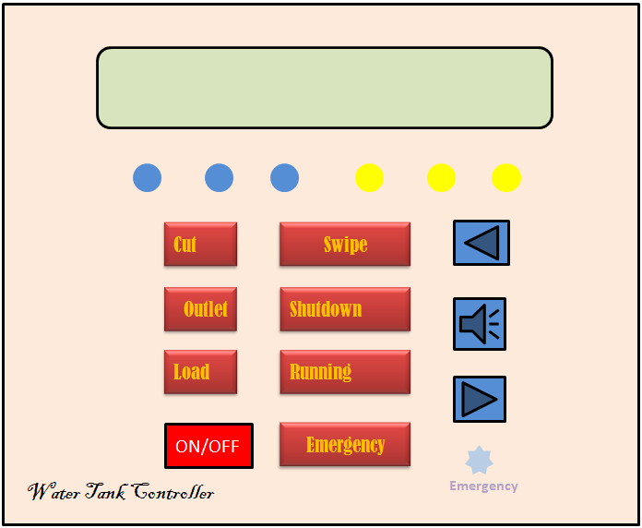

To proceed  further  click on the **ASSIGNMENT** tab on the top or to exit this experiment  click on **HOME**  on the top.

#### [Back to HCI Lab Home Page](http://iitg.vlab.co.in/?sub=72&brch=170)

1.     Redesign the prototype given in the QUIZ using panel layout design guidelines.

2.     Which one of the remote controllers shown below is better?    A or B? Why?

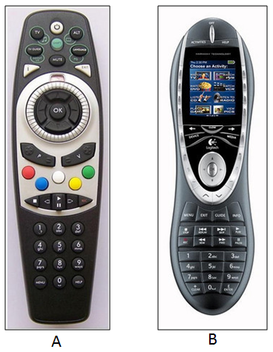

3.     What is the main problem in the control panel shown below?

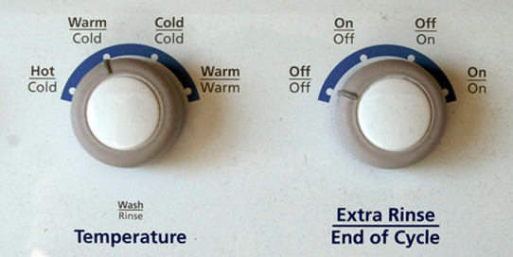

To proceed  further  click on the **REFERENCE** tab on the top or to exit this experiment  click on **HOME**  on the top.

# [Back to HCI Lab Home Page](http://iitg.vlab.co.in/?sub=72&brch=170)

* Minimalistic and intuitive interface design guidelines for consumer electronics devices

    http://www.jot.fm/issues/issue_2007_03/column5.pdf

* Why Consumer Products Have Inferior User Experience?

    http://www.useit.com/alertbox/20040315.html

To proceed  further  click on the **FEEDBACK** tab on the top or to exit this experiment  click on **HOME**  on the top.